1. For , , , and ,
2. For , , , and ,
3. For , , , and ,
4. For , , , and ,
5. For , , , and ,
6. For , , , and ,
7. For , , , and ,
8. For , , , and ,
9. For , , , and ,
10. For , , , and ,
11. For , , , and ,
12. For , , , and ,
13. For , , , and ,
14. For , , , and ,
15. For , , , and ,
16. For , , , and ,
17. For , , , and ,
18. For , , , and ,
19. For,,,and,
20. For,,,and,
21. For,,,and,
22. For,,,and,
23. For,,,and,
24. For,,,and,
25. For,,,and,
26. For,,,and,
27. For,,,and,
28. For,,,and,
29. For,,,and,
30. For,,,and,
31. For,,,and,
32. For,,,and,
33. For,,,and,
34. For,,,and,
35. For,,,and,
36. For,,,and,
37. For,,,and,
38. For,,,and,
39. For,,,and,
40. For,,,and,
41. For,,,and,
42. For,,,and,
43. For,,,and,
44. For,,,and,
45. For,,,and,
46. For,,,and,
47. For,,,and,
48. For,,,and,
49. For,,,and,
50. For,,,and,
51. For,,,and,
52. For,,,and,
53. For,,,and,
54. For,,,and,
55. For,,,and,
56. For,,,and,
57. For,,,and,
58. For,,,and,
59. For,,,and,
60. For,,,and,
61. For,,,and,
62. For,,,and,
63. For,,,and,
64. For,,,and,
65. For,,,and,
66. For,,,and,
67. For,,,and,
68. For,,,and,
69. For,,,and,
70. For,,,and,
71. For,,,and,
72. For,,,and,
73. For,,,and,
74. For,,,and,
75. For,,,and,
76. For,,,and,
77. For,,,and,
78. For,,,and,
79. For,,,and,
80. For,,,and,
81. For,,,and,
82. For,,,and,
83. For,,,and,
84. For,,,and,
85. For,,,and,
86. For $i_{n}=N$, $j_{n}=0$, $x_{n}=0$,and $y_{n}=4$,
$$\left[λ_{H-n}+λ_{L-n}+β_{n}+\left(N-1\right)α_{Hn}+\left(1-θ_{Hn}\right)μ_{Hn}+θ_{Hn}μ_{Hn}\right]π\left(N, 0, 0, 4\right) \\ =θ_{Hn}λ_{H-n}π\left(N-1, 0, 0, 0\right)+λ_{H-n}π\left(N-1, 0, 0, 4\right)+Nα_{Hn}π\left(N+1, 0, 0, 4\right)+ \\ α_{Ln}π\left(N, 1, 0, 4\right)+θ_{Hn}μ_{Hn}π\left(N+1, 0, 0, 2\right)+θ_{Hn}μ_{Ln}π\left(N, 1, 0, 1\right)+ \\ θ_{Hn}μ_{Hn}π(N+1, 0, 0, 4)+θ_{Hn}μ_{Ln}π(N, 1, 0, 3).$$

87. For $i_{n}=N+1$, $j_{n}=0$, $x_{n}=0$,and $y_{n}=4$,
$$[β_{n}+Nα_{Hn}+\left(1-θ_{Hn}\right)μ_{Hn}+θ_{Hn}μ_{Hn}]π\left(N+1, 0, 0, 4\right) \\ =λ_{H-n}π(N, 0, 0, 4).$$

88. For $i_{n}=1$, $j_{n}=0$, $1≤x_{n}≤K-1$,and $y_{n}=4$,
$$(λ_{H-n}+λ_{L-n}+β_{n}+μ_{Hn})π\left(1, 0, x_{n}, 4\right) \\ =β_{n}π\left(1, 0, x_{n}-1, 4\right)+α_{Hn}π\left(2, 0, x_{n}, 4\right)+α_{Ln}π(1, 1, x_{n}, 4).$$

89. For $i_{n}=1$, $1≤j_{n}≤N-1$, $1≤x_{n}≤K-1$,and $y_{n}=4$,
$$\left(λ_{H-n}+λ_{L-n}+β_{n}+j_{n}α_{Ln}+μ_{Hn}\right)π\left(1, j_{n}, x_{n}, 4\right) \\ =λ_{L-n}π\left(1, j_{n}-1, x_{n}, 4\right)+β_{n}π\left(1, j_{n}, x_{n}-1, 4\right)+α_{Hn}π\left(2, j_{n}, x_{n}, 4\right)+ \\ (j_{n}+1)α_{Ln}π(1, j_{n}+1, x_{n}, 4).$$

90. For $i_{n}=1$, $j_{n}=N$, $1≤x_{n}≤K-1$,and $y_{n}=4$,
$$(β_{n}+Nα_{Ln}+μ_{Hn})π\left(1, N, x_{n}, 4\right) \\ =λ_{L-n}π(1, N-1, x_{n}, 4)+β_{n}π(1, N, x_{n}-1, 4).$$

91. For $2≤i_{n}≤N$, $j_{n}=0$, $1≤x_{n}≤K-1$,and $y_{n}=4$,
$$\left[λ_{H-n}+λ_{L-n}+β_{n}+\left(i_{n}-1\right)α_{Hn}+μ_{Hn}\right]π\left(i_{n}, 0, x_{n}, 4\right) \\ =λ_{H-n}π\left(i_{n}-1, 0, x_{n}, 4\right)+β_{n}π\left(i_{n}, 0, x_{n}-1, 4\right)+ \\ i_{n}α_{Hn}π(i_{n}+1, 0, x_{n}, 4)+α_{Ln}π(i_{n}, 1, x_{n}, 4).$$

92. For $2≤i_{n}≤N-1$, $1≤j_{n}≤N-i_{n}$, $1≤x_{n}≤K-1$,and $y_{n}=4$,
$$\left[λ_{H-n}+λ_{L-n}+β_{n}+\left(i_{n}-1\right)α_{Hn}+j_{n}α_{Ln}+μ_{Hn}\right]π\left(i_{n}, j_{n}, x_{n}, 4\right) \\ =λ_{H-n}π\left(i_{n}-1, j_{n}, x_{n}, 4\right)+λ_{L-n}π\left(i_{n}, j_{n}-1, x_{n}, 4\right)+β_{n}π\left(i_{n}, j_{n}, x_{n}-1, 4\right)+ \\ i_{n}α_{Hn}π(i_{n}+1, j_{n}, x_{n}, 4)+(j_{n}+1)α_{Ln}π(i_{n}, j_{n}+1, x_{n}, 4).$$

93. For $2≤i_{n}≤N$, $j_{n}=N-i_{n}+1$, $1≤x_{n}≤K-1$,and $y_{n}=4$,
$$\left[β_{n}+\left(i_{n}-1\right)α_{Hn}+\left(N-i_{n}+1\right)α_{Ln}+μ_{Hn}\right]π\left(i_{n}, N-i_{n}+1, x_{n}, 4\right) \\ =λ_{H-n}π\left(i_{n}-1, N-i_{n}+1, x_{n}, 4\right)+λ_{L-n}π\left(i_{n}, N-i_{n}, x_{n}, 4\right)+ \\ β_{n}π(i_{n}, N-i_{n}+1, x_{n}-1, 4).$$

94. For $i_{n}=N+1$, $j_{n}=0$, $1≤x_{n}≤K-1$,and $y_{n}=4$,
$$(β_{n}+Nα_{Hn}+μ_{Hn})π\left(N+1, 0, x_{n}, 4\right) \\ =λ_{H-n}π(N, 0, x_{n}, 4)+β_{n}π(N+1, 0, x_{n}-1, 4).$$

95. For $i_{n}=1$, $j_{n}=0$, $x_{n}=K$,and $y_{n}=4$,
$$(λ_{H-n}+λ_{L-n}+μ_{Hn})π\left(1, 0, K, 4\right) \\ =β_{n}π(1, 0, K-1, 4)+α_{Hn}π(2, 0, K, 4)+α_{Ln}π(1, 1, K, 4).$$

96. For $i_{n}=1$, $1≤j_{n}≤N-1$, $x_{n}=K$,and $y_{n}=4$,
$$\left(λ_{H-n}+λ_{L-n}+j_{n}α_{Ln}+μ_{Hn}\right)π\left(1, j_{n}, K, 4\right) \\ =λ_{L-n}π\left(1, j_{n}-1, K, 4\right)+β_{n}π\left(1, j_{n}, K-1, 4\right)+α_{Hn}π\left(2,j_{n}, K, 4\right)+ \\ (j_{n}+1)α_{Ln}π(1, j_{n}+1, K, 4).$$

97. For $i_{n}=1$, $j_{n}=N$, $x_{n}=K$,and $y_{n}=4$,
$$(Nα_{Ln}+μ_{Hn})π\left(1, N, K, 4\right) \\ =λ_{L-n}π(1, N-1, K, 4)+β_{n}π(1, N, K-1, 4).$$

98. For $2≤i_{n}≤N$, $j_{n}=0$, $x_{n}=K$,and $y_{n}=4$,
$$\left[λ_{H-n}+λ_{L-n}+\left(i_{n}-1\right)α_{Hn}+μ_{Hn}\right]π\left(i_{n}, 0, K, 4\right) \\ =λ_{H-n}π\left(i_{n}-1, 0, K, 4\right)+β_{n}π\left(i_{n}, 0, K-1, 4\right)+i_{n}α_{Hn}π\left(i_{n}+1, 0, K, 4\right)+ \\ α_{Ln}π\left(i_{n}, 1, K, 4\right).$$

99. For $2≤i_{n}≤N-1$, $1≤j_{n}≤N-i_{n}$, $x_{n}=K$,and $y_{n}=4$,

$\left[λ_{H-n}+λ_{L-n}+\left(i_{n}-1\right)α_{Hn}+j_{n}α_{Ln}+μ_{Hn}\right]π\left(i_{n}, j_{n}, K, 4\right)$ $$=λ_{H-n}π\left(i_{n}-1, j_{n}, K, 4\right)+λ_{L-n}π\left(i_{n}, j_{n}-1, K, 4\right)+β_{n}π\left(i_{n}, j_{n}, K-1, 4\right)+ \\ i_{n}α_{Hn}π\left(i_{n}+1, j_{n}, K, 4\right)+\left(j_{n}+1\right)α_{Ln}π(i_{n}, j_{n}+1, K, 4).$$

1. For $2≤i_{n}≤N$, $j_{n}=N-i_{n}+1$, $x_{n}=K$,and $y_{n}=4$,

$\left[\left(i_{n}-1\right)α_{Hn}+\left(N-i_{n}+1\right)α_{Ln}+μ_{Hn}\right]π\left(i_{n}, N-i_{n}+1, K, 4\right)$ $$=λ_{H-n}π\left(i_{n}-1, N-i_{n}+1, K, 4\right)+λ_{L-n}π\left(i_{n}, N-i_{n}, K, 4\right)+ \\ β_{n}π\left(i_{n}, N-i_{n}+1, K-1, 4\right).$$

1. For $i_{n}=N+1$, $j_{n}=0$, $x_{n}=K$,and $y_{n}=4$,

$(Nα_{Hn}+μ_{Hn})π\left(N+1, 0, K, 4\right)$ $$=λ_{H-n}π(N, 0, K, 4)+β_{n}π(N+1, 0, K-1, 4).$$

Since there are many equations presented above, discussing each one separately would be challenging. Therefore, we focus on a relatively complicated case, specifically case *B38*, to provide an illustrative example. This state occurs when there are more than or equal to two but less than or equal to N HP packets and 0 LP packet in the system, and there are more than 1 seat left in the packet queue, while the energy queue is empty. The HP packet being served in the server is using the harvested energy. The corresponding detailed state transition diagram can be found in Fig. 3 - 5.

1. For $2≤i_{n}≤N$, $j_{n}=0$, $x_{n}=0$,and $y_{n}=2$,

$$\left[λ_{H-n}+λ_{L-n}+β_{n}+\left(i_{n}-1\right)α_{Hn}+\left(1-θ_{Hn}\right)μ_{Hn}+θ_{Hn}μ_{Hn}\right]π\left(i_{n}, 0, 0, 2\right) \\ =λ_{H-n}π\left(i_{n}-1, 0, 0, 2\right)+β_{n}π\left(i_{n}, 0, 0, 0\right)+i_{n}α_{Hn}π\left(i_{n}+1, 0, 0, 2\right)+ \\ α_{Ln}π\left(i_{n}, 1, 0, 2\right)+μ_{Hn}π\left(i_{n}+1, 0, 1, 2\right)+μ_{Ln}π\left(i_{n}, 1, 1, 1\right)+ \\ μ_{Hn}π\left(i_{n}+1, 0, 1, 4\right)+μ_{Ln}π\left(i_{n}, 1, 1, 3\right).$$

*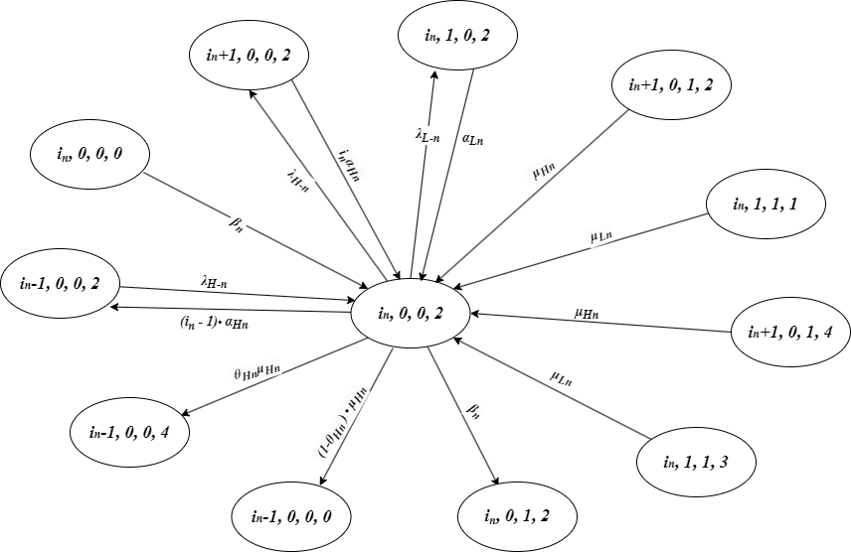*

Fig. 3 - 5: The state transition diagram for $2≤i_{n}≤N$, $j_{n}=0$, $x_{n}=0$,and $y_{n}=2$*.*